**CompanyX**

**XNMS**

This document describes software/hardware designs of the application named XNMS developed by CompanyX. XNMS application scans devices in the network and collect the information it needs. After that, it analyses the collected informations. As a result of this analysis, for errors previously defined in the system, it resolves the problems by sending the necessary parameters to the devices. If the error is not defined in the system, an alarm is generated for users and a manual review is requested. Thus, new error codes are defined in the system to ensure that the relevant error is fixed automatically for future.

**High Level Design (HLD)**

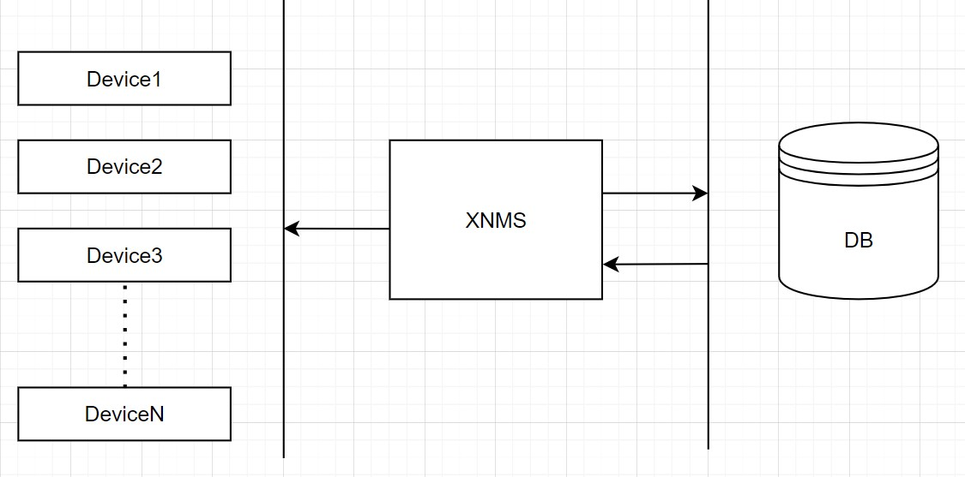

**HW & Network Design**

**diyagram, plan, çizgi, dikdörtgen içeren bir resim

Açıklama otomatik olarak oluşturuldu**

**The XMNS application consists of the following modules;**

* **Collect Data Module:** This module scans devices on the network to collect data. It gets device informations such as signal status, activity status, incoming and outgoing data traffic details, power supply status etc, to save into the database.
* **Data Analysing Module :** The module is designed to analyze collected data, identify performance issues, and generate reports. Also, it creates a summary table to provide simplicity.
* **Problem Solving Module:** It evaluates the problems detected by the Data Analysis Module. It automatically corrects problem according to defined error codes and generate alert for others. Additionally, all results are reported.

**Low Level Design (LLD)**

* Collect Data Module (CDM)

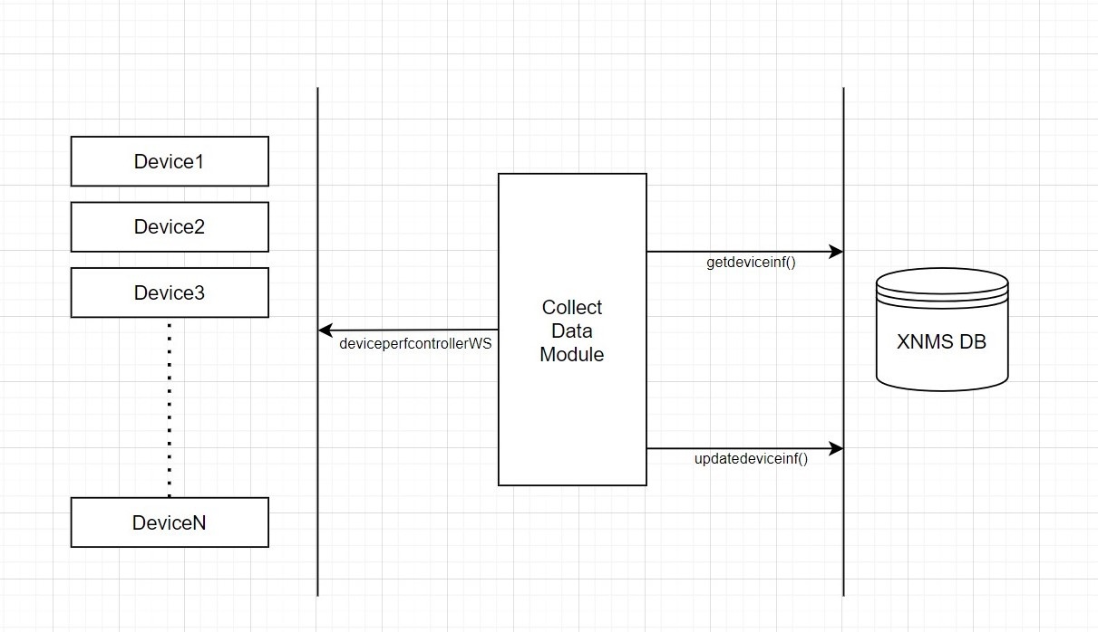

* Data Analysing Module (DAM)

metin, diyagram, ekran görüntüsü, dikdörtgen içeren bir resim

Açıklama otomatik olarak oluşturuldu

* Problem Solving Module(PSM)

metin, diyagram, plan, paralel içeren bir resim

Açıklama otomatik olarak oluşturuldu

**Connectivity Matrix(CM)**

|  |  |  |  |  |  |
| --- | --- | --- | --- | --- | --- |
|  | CDM | DAM | PSM | XMNSDB | DEVICES |
| CDM | 0 | 0 | 0 | 1 | 1 |
| DAM | 0 | 0 | 0 | 1 | 0 |
| PSM | 0 | 0 | 0 | 1 | 1 |
| XMNSDB | 1 | 1 | 1 | 0 | 0 |
| DEVICES | 1 | 0 | 1 | 0 | 0 |

**Flow Diagram**

ekran görüntüsü, çizgi, tasarım, sanat içeren bir resim

Açıklama otomatik olarak oluşturuldu